Date:22-10-2026
CO 2 ASSESSMENT TOOL 1

ANALYTICAL PROBLEM SOLVING

COURSE NAME: NATURAL LANGUAGE PROCESSING

COURSECODE: DSA0308

NAME:BODDU RAMYA REG.NO: 192424183

- Given the input words: “connected”, “connecting”, “connection”, design a morphological analysis pipeline for a document indexing system.
Problem Statement
Design and implement a Python-based morphological analysis pipeline for a document indexing system that decomposes the words “connected,” “connecting,” and “connection” into roots and suffixes, classifies suffixes as inflectional or derivational, normalizes the words to a common base form, and displays the parsed structure and normalized output in a properly aligned tabular format.
Code
import pandas as pd
words = ["connected", "connecting", "connection"]
def analyze_word(word):
if word == "connected":
return [word, "connect", "ed", "Inflectional", "connect"]
elif word == "connecting":
return [word, "connect", "ing", "Inflectional", "connect"]
elif word == "connection":
return [word, "connect", "ion", "Derivational", "connect"]
results = [analyze_word(word) for word in words]
df = pd.DataFrame(results, columns=[
"Input Word", "Root", "Suffix",
"Suffix Type", "Normalized Form"
])
print("\nMorphological Analysis Pipeline\n")
print(df.to_string(index=False, col_space=12, justify="center"))
Output
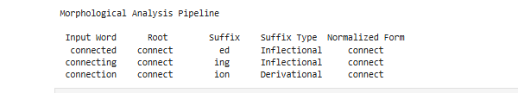
- Given the input words: “unhappy”, “happiness”, “happily”, design a morphological parsing module for sentiment analysis.

Problem Statement
Design and implement a Python-based morphological parsing module for sentiment analysis using the input words “unhappy,” “happiness,” and “happily.” The program should identify prefixes, suffixes, and root words using rule-based decomposition, classify each transformation as inflectional or derivational, maintain a common base form for semantic consistency, and display the morphological breakdown in a properly aligned tabular format.
Code
words = ["unhappy", "happiness", "happily"]
def analyze_word(word):
if word == "unhappy":
prefix = "un"
root = "happy"
suffix = "None"
transformation = "Derivational"
elif word == "happiness":
prefix = "None"
root = "happy"
suffix = "ness"
transformation = "Derivational"
elif word == "happily":
prefix = "None"
root = "happy"
suffix = "ly"
transformation = "Derivational"
return [word, prefix, root, suffix, transformation]
print("Morphological Parsing for Sentiment Analysis\n")
print(f"{'Word':<12}{'Prefix':<12}{'Root':<12}"
f"{'Suffix':<12}{'Transformation':<18}")
print("-" * 66)
for word in words:
result = analyze_word(word)
print(f"{result[0]:<12}{result[1]:<12}{result[2]:<12}"
f"{result[3]:<12}{result[4]:<18}")
Output
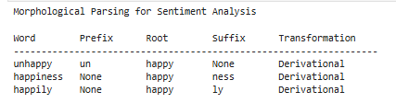
- Given the input words: “played”, “player”, “playing”, design a stemming-based preprocessing module for a search engine.

Problem Statement
Design and implement a Python-based stemming preprocessing module for a search engine using the input words “played,” “player,” and “playing.” The program should apply morphological rules to remove suffixes, identify the stem, classify each transformation as inflectional or derivational, and display the original word, extracted stem, removed affix, transformation type, and normalized form in a properly aligned tabular format.
Code
words = ["played", "player", "playing"]
def analyze_word(word):
if word == "played":
stem = "play"
affix = "ed"
kind = "Inflectional"
elif word == "player":
stem = "play"
affix = "er"
kind = "Derivational"
elif word == "playing":
stem = "play"
affix = "ing"
kind = "Inflectional"
normalized = stem
return [word, stem, affix, kind, normalized]
print("Stemming-Based Search Engine Preprocessing\n")
print(f"{'Original Word':<16}{'Stem':<12}"
f"{'Removed Affix':<16}{'Transformation':<18}"
f"{'Normalized Form':<16}")
print("-" * 78)
for word in words:
result = analyze_word(word)
print(f"{result[0]:<16}{result[1]:<12}"
f"{result[2]:<16}{result[3]:<18}"
f"{result[4]:<16}")
Output
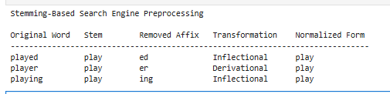
- Given the input words: “writes”, “writing”, “written”, design a finite-state morphological parsing module for a text processing system.

Problem Statement
Design and implement a Python-based finite-state morphological parser for the input words “writes,” “writing,” and “written.” The program should use state transitions to identify suffixes and handle irregular verb forms, classify each word as a regular or irregular inflection, extract the common root “write,” and display the state transition path, morphological components, root form, and normalized output in a properly aligned tabular format
Code
words = ["writes", "writing", "written"]
def parse_word(word):
if word == "writes":
path = "q0 -> q1 -> q2"
root = "write"
suffix = "s"
pattern = "Regular"
breakdown = "write + s"
elif word == "writing":
path = "q0 -> q1 -> q2"
root = "write"
suffix = "ing"
pattern = "Regular"
breakdown = "write + ing"
elif word == "written":
path = "q0 -> q1 -> q3"
root = "write"
suffix = "ten"
pattern = "Irregular"
breakdown = "write -> written"
return [word, path, breakdown, root, suffix, pattern, root]
print("Finite-State Morphological Parsing\n")
print(f"{'Word':<12}{'State Path':<20}{'Breakdown':<20}"
f"{'Root':<10}{'Suffix':<10}{'Pattern':<12}"
f"{'Normalized':<12}")
print("-" * 96)
for word in words:
result = parse_word(word)
print(f"{result[0]:<12}{result[1]:<20}{result[2]:<20}"
f"{result[3]:<10}{result[4]:<10}{result[5]:<12}"
f"{result[6]:<12}")
Output
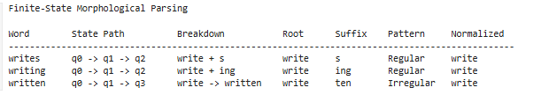
5. Given the input words: “relational”, “relation”, “relate”, design a Porter Stemmer-based preprocessing module for document retrieval.

Problem Statement
Design and implement a Python-based Porter Stemmer preprocessing module for document retrieval using the input words “relational,” “relation,” and “relate.” The program should apply stemming rules sequentially, display the applied rules and intermediate forms, and produce the final normalized stem for each word in a properly aligned tabular format suitable for document indexing and retrieval.
Code
from nltk.stem import PorterStemmer
words = ["relational", "relation", "relate"]
stemmer = PorterStemmer()
def analyze_word(word):
steps = []
if word == "relational":
steps.append("relational -> relate (ational -> ate)")
steps.append("relate -> relat (e removed)")
elif word == "relation":
steps.append("relation -> relat (ion removed)")
elif word == "relate":
steps.append("relate -> relat (e removed)")
final_stem = stemmer.stem(word)
return [word, "; ".join(steps), final_stem]
print("Porter Stemmer Preprocessing\n")
print(f"{'Original Word':<18}{'Stemming Steps':<48}"
f"{'Final Stem':<12}")
print("-" * 78)
for word in words:
result = analyze_word(word)
print(f"{result[0]:<18}{result[1]:<48}"
f"{result[2]:<12}")
Output
